Name: ____________________________

**Your English bulldogs need a new piece of clothes. What size are you going to order for Benji, Ozzy and Whitney?**

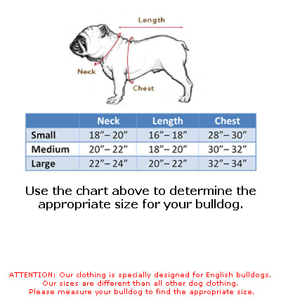

source:https://www.google.hu/search?q=diagram+in+English&biw=1024&bih=643&espv=2&source=lnms&tbm=isch&sa=X&ved=0ahUKEwiigJHGzPXLAhVsCpoKHcMNC9kQ_AUIBigB#imgrc=YkP14gRQj8sdOM%3A

**Benji** = neck: 17”, length: 18”, chest: 30” Size: ____________

**Ozzy** = neck: 25”, length: 21”, chest: 35” Size: _____________

**Whitney** = neck: 20”, length: 18”, chest: 33” Size: _____________

**Parker and Fred has got a Hungarian owner. She sent their measurements by e-mail:**

(1”=25,4 mm=2,54 cm)

**Parker** = neck: 53,34 cm; length: 45,72 cm; chest: 78,74 cm. Size: ____________

**Fred** = neck: 63,5 cm; lenght: 55,88 cm; chest: 81,28 cm. Size: ____________

**True or False?**

Whitney is bigger than Benji, but smaller than Fred. ________________

Ozzy is the longest dog. _____________

Parker is shorter than Fred, but longer than Benji. _______________

Benji is the smallest dog. ___________________ Total: 9/

|  |  |  |
| --- | --- | --- |
|  |  |  |
|  |  |  |
|  |  |  |
|  |  |  |
|  |  |  |